THE NEBULA BOT

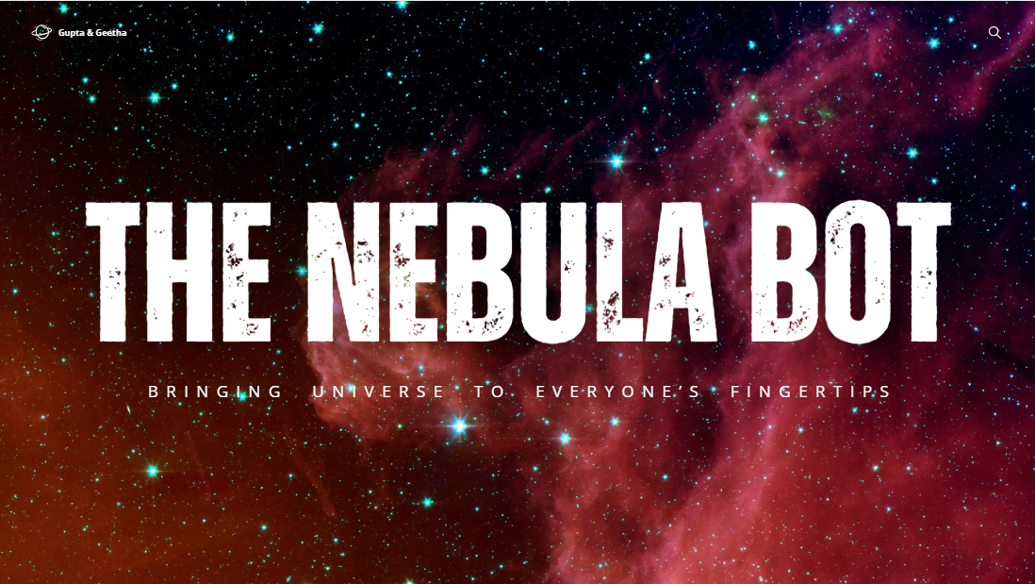

**The Nebula** Bot is an astronomy educational chatbot designed to inspire curiosity and provide engaging learning experiences about the cosmos. It serves as an interactive guide, offering insights into celestial objects, space phenomena, and the vast mysteries of the universe. Whether it’s simplifying the lifecycle of stars, explaining black holes, or assisting with stargazing tips, Nebula Bot makes astronomy accessible to students, educators, and enthusiasts alike. With its dynamic and interactive interface, the bot ensures that users of all knowledge levels can dive into the wonders of space in an intuitive and enjoyable way.

The development of Nebula Bot utilized powerful web technologies like **HTML, CSS**, and **JavaScript**, combined with the robust features of the Botpress framework. HTML and CSS were employed to craft a visually appealing and user-friendly interface, while JavaScript enabled dynamic interactivity to create a seamless chatbot experience. Leveraging Botpress’s capabilities, the bot was programmed with intelligent conversational flows, allowing it to provide accurate responses and engaging interactions. By integrating cutting-edge technology with a passion for education, Nebula Bot is a testament to how technology can simplify and enhance our understanding of the cosmos